An efficient search strategy does not develop spontaneously with repeated exposure to simulated visual deficit.

Anna Nowakowska

Alasdair D.F. Clarke

Arash Sahraie

Amelia R. Hunt

University of Aberdeen

**Abstract**

Healthy participants with simulated visual deficit (hemianopia) fail to adopt efficient eye movement strategies when searching for a target object. A possible explanation is that participants are not exposed to the deficit long enough for coping strategies to develop. In the current study, visual information in one hemifield was removed or degraded while participants searched for a line tilted 45° to the right among lines of varying degree of tilt. Participants completed five testing sessions over five consecutive days and received monetary payment for improvements in performance. Participants did improve on the task in terms of reaction time and accuracy, but these improvements were mainly associated with improved peripheral vision rather than a change in search strategy. Participants persisted in directing a large proportion of saccades to the sighted field under conditions where little or no new information about the target location would be gained by doing so. However, more eye movements were directed into the blind field in the first compared to the last session, and this small improvement in strategy may have improved their performance on an object naming task which participants completed before and after training.

Key words:

Visual search, optimality, blindsight, hemianopia

Homonymous hemianopia is a loss of vision in half of the visual field in both eyes following unilateral lesion of the post-chiasmic visual pathway. The visual field loss experienced by patients has a profound impact on patient’s day-to-day functioning and is often associated with difficulties carrying activities of daily living (ADL) such as reading (Schuett, Heywood, Kentridge, Zihl, 2008), driving (Papageorgiou, 2007), and navigating in familiar and unfamiliar environments (Han, Law-Gibson, Reding, 2002; Kerkhoff, 2000; Papageorgiou, Hardiess, Schaeffel, Wiethoelter, Karnath, Mallot, Schoenfisch, Schiefer, 2007; Zihl, 1995). Deficits in ADLs are mainly associated with abnormal eye-guidance and visual exploration strategies that hemianopic patients develop over time. Patients with established hemianopia tend to scan the visual world in a more haphazard and disorganised way than healthy controls, with frequent re-fixations and imprecise saccades, showing poorer target detection and longer reaction times (Meienberg, Zangemeister, Rosenberg, Hoyt & Stark, 1981; Zihl, 1995; Zihl, 1999). While viewing naturalistic scenes, patients tend to fixate different spatial regions and make more fixations of shorter duration compared to healthy observers (Ishiai, Furukawa, & Tsukagoshi, 1987; Pambakian, Wooding, Morland, Kennard & Mannan, 2000). Patients also direct more saccades towards their damaged hemifield, with these saccades being of shorter latency and amplitude (Pambakian et al., 2000).

Some patients spontaneously compensate for their visual field loss over time, by adopting more efficient eye movement strategies (Zihl, 1999; Zihl & von Cramon, 1985), however an estimated 60% of patients continue using abnormal visual scanning strategies when searching for a target object (Zihl, 1995). One technique that has been shown to improve patient’s visual exploratory abilities is visual search training, which encourages patients to make exploratory eye movements into the blind field (Pambakian, Currie & Kennard, 2005; Pambakian, Mannan, Hodgson & Kennard, 2004;). In laboratory settings improvements have been noted after as little as 7 hours of practice (Schuett, 2009), and after only one session of therapy (300 trials) on a real-world task (Jacquin-Courtois, Bays, Salemme, Leff & Husain, 2012). Applying these strategies in real life has been associated with self-reported improvements in general functioning (Mannan, Pambakian & Kennard, 2010; Zihl, 1981).

In training studies, participants are typically given specific instructions and encouraged to use a particular strategy. Is this required, or can an efficient strategy develop spontaneously simply through exposure to the deficit and practice with a specific search task? An influential model of visual search suggests that healthy human observers can use optimal strategies without specific instructions (Najemnik & Geisler, 2005; 2008), but others have demonstrated surprising failures to direct eye movement to locations that could maximise search performance (Clarke & Hunt, 2016; Morvan & Maloney, 2012; Nowakowska et al., submitted; Verghese, 2012). We recently investigated whether healthy participants can spontaneously adopt effective strategies to compensate for information loss and showed that healthy participants with simulated visual deficit (hemianopia) are unable to adopt efficient eye movement strategies when searching for a target object (Nowakowska, Clarke, Sahraie & Hunt, in press). In that study, visual information in one hemifield was removed or degraded while participants searched for a line tilted 45° to the right among lines of varying degree of tilt or an angry face among neutral faces. A rational search strategy would be to look towards the degraded field, and to do so to an increasing extent the more it is degraded. We found the opposite: there was a bias towards the sighted field, and the proportion of saccades directed towards the blind field increased with the amount of information available in that field. We also kept the target constant but varied the background pattern to observe the effect on search strategies. The logic was that when the target is difficult to see against a complex background, it does not matter whether participants search the sighted or blind field first, as they need to serially inspect each location to determine if the target is present or not. If the background is simple, however, and the target is consequently highly visible in the periphery, participants can quickly ascertain from a central point whether or not the target is present or absent in the sighted field. Eye movements towards the sighted field will provide no new information under these circumstances. Nonetheless, our participants frequently directed eye movements towards the sighted field even though the target was obviously absent, exhibiting surprisingly inefficient search behaviour.

Our finding that participants fail to adopt efficient strategies to compensate for simulated visual deficits is inconsistent with models suggesting human search is optimal (Najemnik & Geisler, 2005; 2008). These results also justify the use of specialized training for helping patients learn to cope with visual deficits, as they suggest patients otherwise persist in using ineffective strategies. However, it is important to note that simulated hemianopia is an usual circumstance for our healthy participants, and it may not be warranted to conclude that they are sub-optimal at adapting their search after only one session. Therefore, in the current study we investigate whether repeated exposure to a simulated visual field deficit leads to the development of an efficient search strategy. In the main task, completed over five consecutive days, we directly manipulated the visibility of the target, using a search task similar to the one we used in the previous studies of hemianopia (Nowakowska et al., submitted). Participants searched for a line tilted 45 ° to the right hidden amongst distractor lines of varying degree of tilt. Target visibility was manipulated by varying the heterogeneity of the distractor line segment orientations. Participants were rewarded monetarily for improving their search performance from session to session, to encourage them to find strategies to find the target faster.

We also introduced two additional tasks: detection task and object naming, completed only during the first and last session of the experiment. In the detection task, the same search displays as in the training task were shown, but for only 200ms, which is too brief a presentation time for any useful eye movements to be executed. The aims of the detection task were 1) to confirm that participants were able to detect the target in the periphery on homogeneous background, without making any eye movements and 2) to measure the extent to which any improvements in search performance over the five sessions could be due to changes in perceptual sensitivity to the target rather than to changes in eye movement strategies. .In the object naming task, we simply asked participants to view a series of images, each for four seconds, and name as many objects from each image as they could. The goal of this task was to estimate the extent to which any improvements in performance in the training task would transfer to other images/tasks.

**Method**

*Participants.* Seventeen participants (females=15; age range =19-36; mean age=22.8 ± 3.99) completed the experiment. All reported normal or corrected-to-normal vision.

***Search training task***

This task was completed every day for a work week, starting on Monday and finishing on Friday. Each participant was tested under two experimental conditions: *Simulated Hemianopia (SH) and*  *Unmodified* (control). Under the SH condition the eye-tracker sampled the current gaze position online and replaced the part of the display falling to the left or right of current fixation (blocked) with the grey background. In the *Unmodified* condition eye movements were sampled but no mask was applied.

*Apparatus.* The display was presented on a 17inch CRT monitor with a resolution of 1024x768. Stimulus generation, presentation and data collection were controlled by Matlab and the psychophysics toolbox (Brainard, 1997; Pelli, 1997) run on a Powermac. The position of the dominant eye was recorded using a desktop-mounted EyeLink 1000 eye tracker (SR Research, Canada) sampling eye position at 1000Hz. The length of the entire system’s delay was 1.5ms (time taken from registering a new sample to screen update). The participants were asked to respond by pressing either the left arrow key (for target present trials) or right arrow key (for target absent trials) on a standard keyboard.

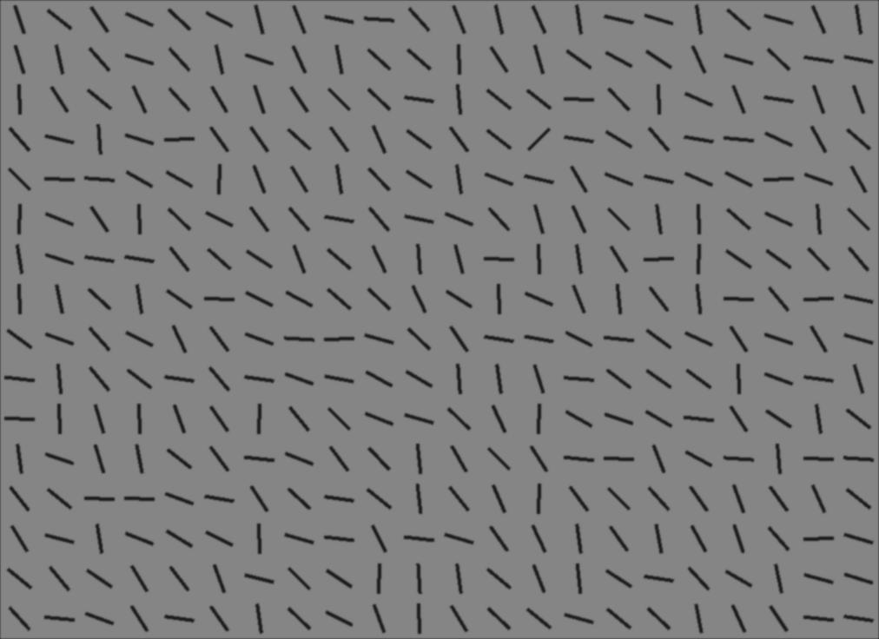

*Figure 1*. Example line segments: left panel represents the stimuli when the target (a line tilted 45˚ to the right) was difficult to find and right panel when the target was easy to find.

*Materials.* The stimuli consisted of 80 pre-generated arrays of line segments. Each line was 1.2cm (1.6°) long. The segments were aligned in 22 columns and 16 rows. The target line was always tilted 45 degrees to the right and the mean distractor angle was perpendicular to the target angle. The target could be located in any of the possible locations apart from the first and last row and column and the middle two rows and columns. Of the 80 images, 40 were target present and 40 target absent. We introduced two levels of search difficulty, with each level corresponding to the distribution from which the distractor line orientation was drawn relative to the target. The distractor angle range of 95° (range of possible distractor angles from the mean orientation) was the hardest condition and the range of 18° was the easiest condition (see Figure 1 for example stimuli). Difficulty included 20 stimuli of each difficulty (in both target present and absent conditions). The target was present 20 times on the left and 20 times on the right hand side of the screen. The lines were located on a uniform grey background. The background and mask luminances were matched (17±1 cd/ m²).

Each participant was tested under 20 experimental conditions: two Mask Types (*Blank*, *Unmodified*) and two Mask Sides (*Left*, *Right*). The same set of line segment stimuli was presented in the three conditions (in random order).

*Procedure.* On arrival at the laboratory each participant was asked to read and sign a consent form and was seated alone in a small low-lit room. On the first session participants were told that they would be doing three tasks: an object-naming task, detection task, and a search task, and their eye movements would be recorded while performing the tasks. They were also told that on the Tuesday, Wednesday and Thursday session they will only do the search task and on Friday they would do all three tasks.

The mask conditions (*Blank* and *Unmodified*) and the location of the mask (left or right) were blocked and the block order was randomized. Participants were informed of the condition before they started each block. Participants were instructed to press a space bar with their left hand to initialize each trial and to press the arrow keys with their right hand. Each trial consisted of a black fixation point (letter x) subtending 1.5x2.5cm (1.9°x3.1°), presented at the centre of the computer screen. On the press of a space bar, the fixation point was immediately replaced by the search array, with the mask applied according to the condition. For example, in the right-side mask block the display was increasingly uncovered as the participants moved their eyes to the far right, and as they moved their eyes to the left the screen was increasingly covered with the mask. The display remained on the screen until the participant made their response, or after 60 seconds had elapsed without a response. The display was replaced with the initial fixation point for the next trial 200ms after the left or right arrow key was pressed. Participants completed three blocks of 80 trials (240 trials total): one block masked to the left, one to the right and one block with no mask ( *Unmodified* condition). The target was present on half of all trials in each block and the participants’ task was to indicate the presence or absence of a target. All participants were asked to respond as quickly and as accurately as possible. Auditory feedback in the form of a beep immediately followed every incorrect key press. Before each block of trials participants underwent a nine-point eye movement calibration sequence. Participants were not given any information about hemianopia or simulated hemianopia until they finished the last session. After participants completed the three tasks and the Monday session was over experimenter reminded participants that they would be paid 20 pounds for their participation in the experiment regardless of their performance. At this point, the experimenter also added that they would also receive additional £5 for any session in which they improved their reaction times compared to their best performance on any previous session, provided their accuracy stayed at least the same as on the first session. Participants were given this information after completing the Monday session to make sure they could not deliberately under-perform on the first to make it easier to improve. Thus participants could be reimbursed a maximum of £40 pounds if they performance improved on every session.

***Detection task***

*Stimuli and procedure.*

The 80 search arrays of line segments we used in this experiment were exactly the same as the ones in the Simulated Hemianopia Task.

Participants were told they would see line segments on the screen for a very short time, and their task was to determine whether a line tilted 45° to the right was present among other lines. Participants were asked to respond as accurately as possible and to guess if not sure about the answer.

Each trial consisted of a black fixation point (letter x) subtending 1.5x2.5cm (1.9°x3.1°), presented at the centre of the computer screen. On the press of a space bar, the stimulus was displayed for 200ms follow by a blank screen. Participants had to press either the left (present) or right (absent) arrow key. Auditory feedback in the form of a beep immediately followed incorrect key presses. Before the start of the experiment participants underwent a five-point calibration sequence. This task was always carried before the three simulated hemianopia blocks on the Monday session and after simulated hemianopia blocks on the Friday session.

***Object Naming task***

This task was introduced to investigate if any improvements in reaction times in the main task ( simulated hemianopia) are also transferrable to other tasks/objects.

*Stimuli and procedure.*

*Figure 2.* Example of images used in the Object Naming Task (original on the left and flipped on the right).

Participants viewed photographic images of scenes for four seconds, after which the image disappeared and participants verbally listed all the objects that they could remember seeing in a particular scene. Participants were encouraged to list as many objects as they could remember. The responses were recorded using voice recorder. For more information on the image set see Clarke et al., 2013). The stimuli were 80 images of natural indoor and outdoor scenes (see example figure X) taken from Clarke, Coco & Keller ( 2013). The images were divided into two sets. Each of the images in the two sets was also flipped to avoid any left/right bias in the amount of objects presented. Therefore we had four sets in total (Original Images Set 1, Original Images Set 2, Flipped Images Set 1 and Flipped Images Set 2). If participant were tested with Original Set 1 on the first session, they would be tested with Flipped Set 2 on the second session, similarly if they saw Flipped Set 1 on the first session they would see Original Set 2 on the second (the full randomisation is shown in table 1 in the supplementary materials). Additionally, we simulated hemianopia while participants were doing this task, in exactly the same way as in search training task). Participants who experienced left hemianopia in the first session experienced right simulated hemianopia in the last session, and vice-versa. Thus in this task we had two hemianopia types (Left, Right), two image types (Original, Flipped), and two image sets (Set One, Set Two). For the purpose of data analysis none of these variables were of theoretical interest so we collapsed across them and only included just one independent variable: Session (1 vs. 2).

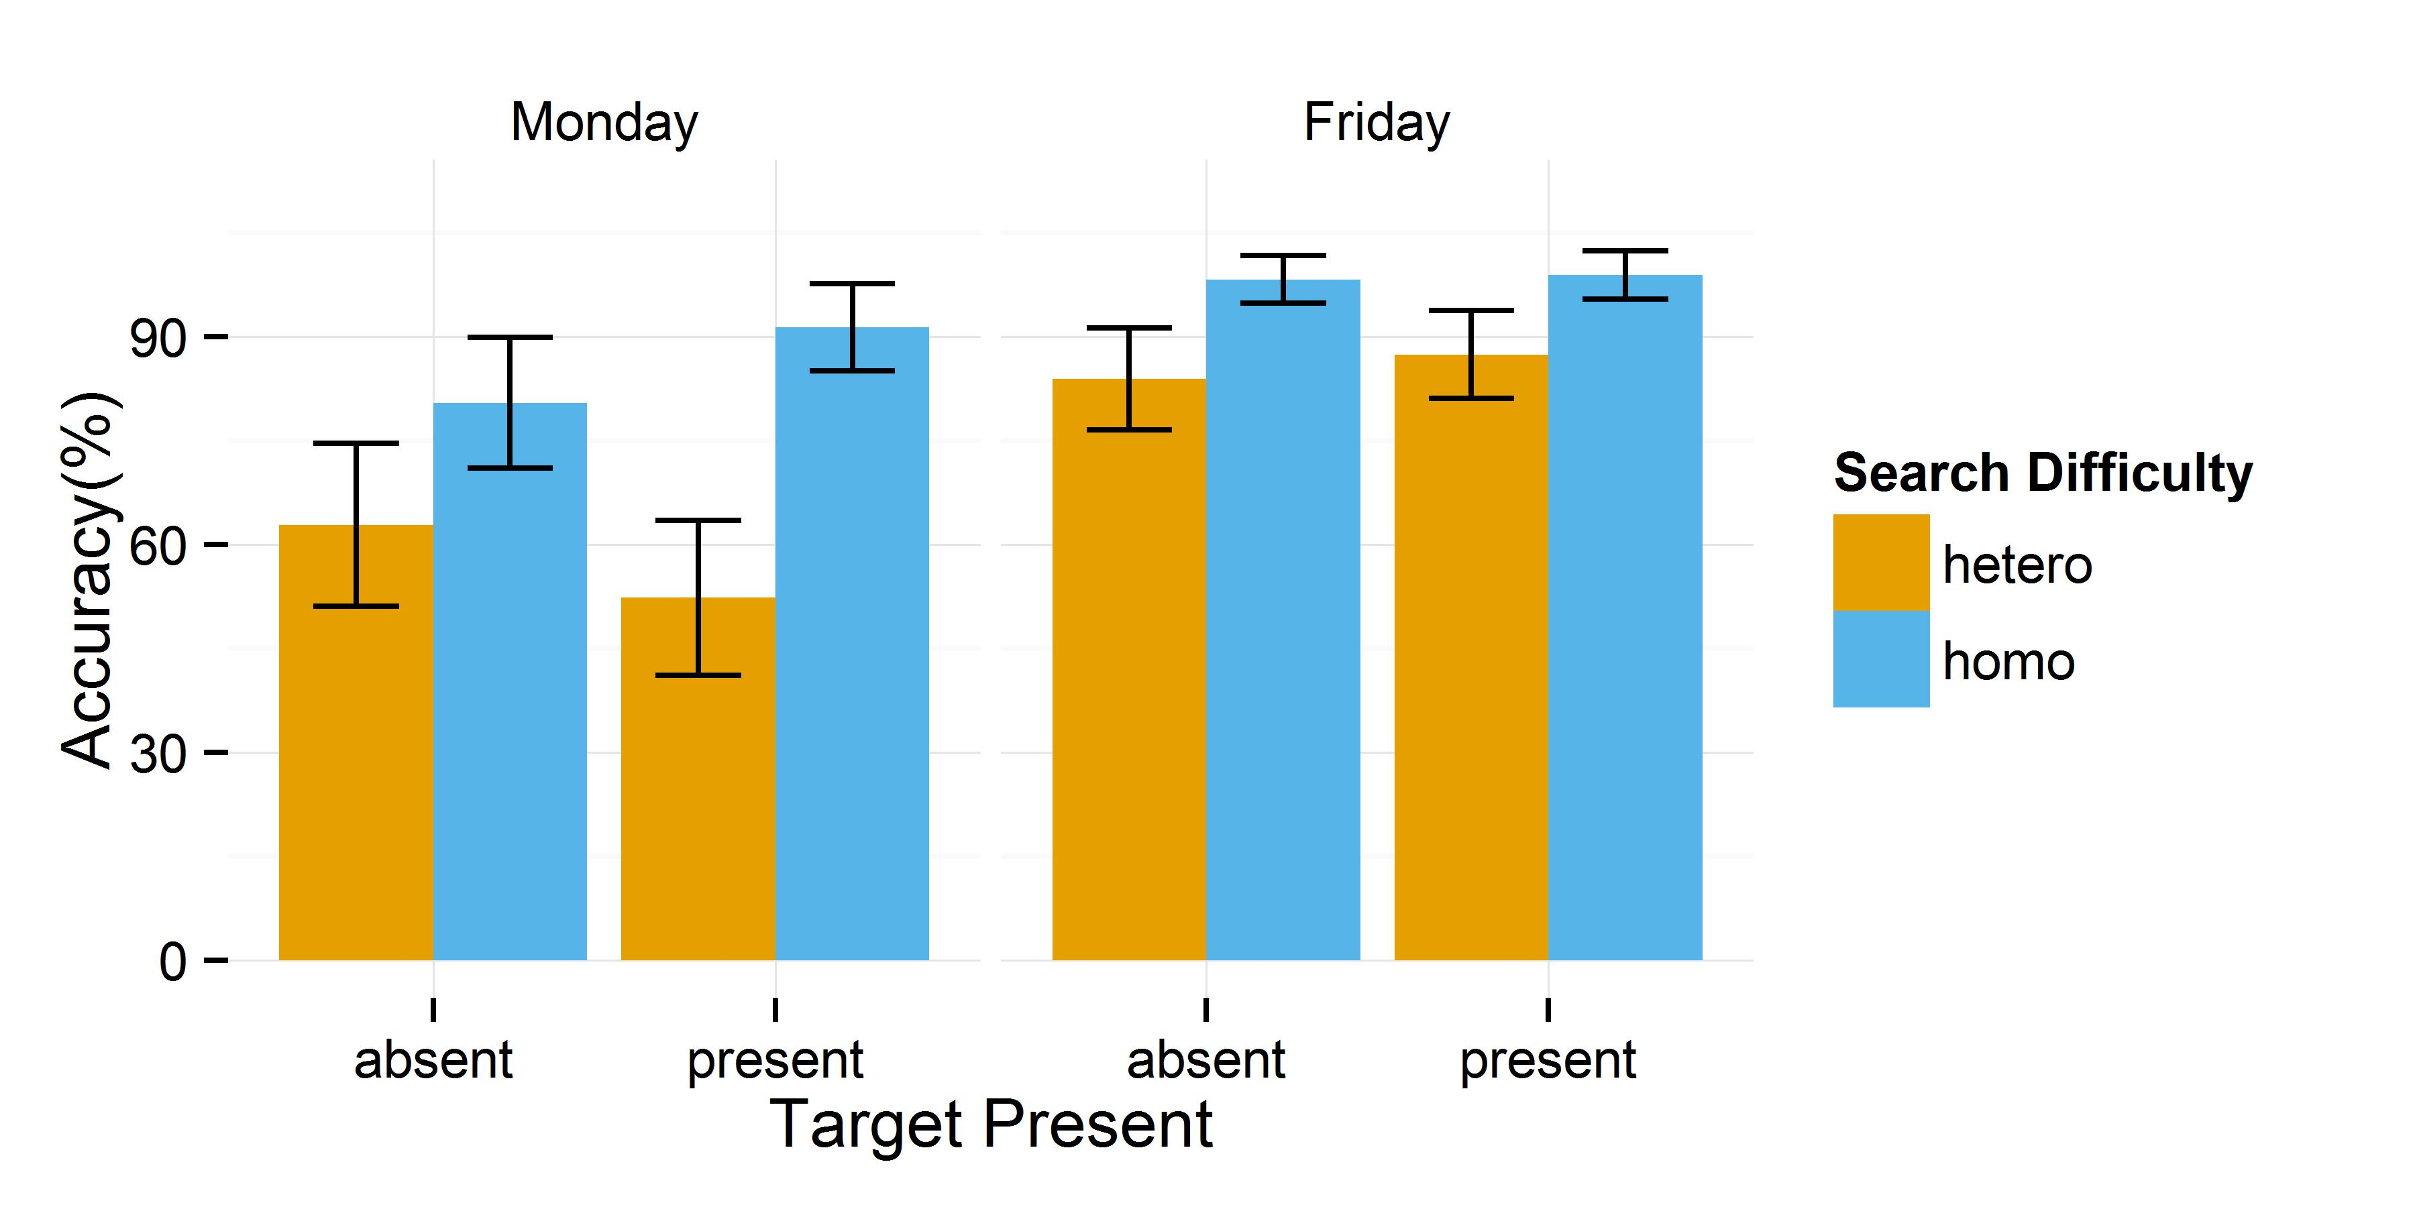**Results**

*Figure 3.* Accuracy data from the detection task shown separately on Monday and Friday for target absent and present trials and two search difficulties. The error bars show 95% confidence intervals

The accuracy data from the detection task on two sessions are shown in figure x.

Accuracy data was calculated for each participant and was analysed using a 2x2x2 repeated measures ANOVA with Search Difficulty (*Homogeneous, Heterogeneous*), Target Present (*Present*, *Absent)* and Session (*Monday, Friday*) as factors.. This analysis revealed a statistically significant main effect of Search Difficulty [*F*(1,16)=89.95, *p*<.001, $ɳ_{p}^{2}$ =.85], and Session [*F*(1,16)=62.29, *p*<.001, $ɳ_{p}^{2}$ =.80], but not significant effect of Target Present[*F*(1,16)=.12, *p*=.73, $ɳ_{p}^{2}$ =.007] and no statistically significant interaction between the three factors [*F*(1,16)=3.09, *p*=.10, $ɳ_{p}^{2}$ =.16]. Paired sample t-test further showed that on Monday session participants were significantly more accurate on homogeneous displays, regardless whether the target was absent [*t*(16)=2.43,*p*=.03 or present [*t*(16)=4.41,*p*<.001, similarly on Friday session participants were significantly more accurate on homogeneous displays, regardless whether the target was absent [*t*(16)=4.14,*p*=.001 or present [*t*(16)=4.47,*p*<.001. Then we split these data by difficulty instead. On homogeneous trials we observe participants’ accuracy increased significantly on Friday session (compared to the Monday one) when the target was absent [*t*(16)=3.71,*p*=.002] and when it was present [*t*(16)=2.11, *p*=.51]. On heterogeneous trials we observe participants’ accuracy increased significantly on Friday session (compared to the Monday one) both when the target was present [*t*(16)=7.07, *p*<.001] and absent [*t*(16)=2.80, *p*=.01].

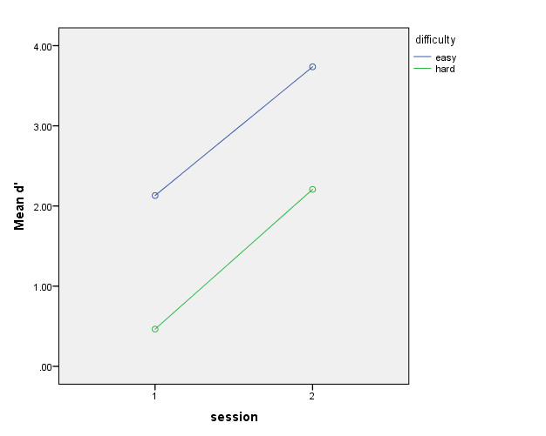

|  |  |  |  |
| --- | --- | --- | --- |
| **Descriptive Statistics** | | | |
|  | Mean | Std. Deviation | N |
| oneEasy | 2.1306 | 1.19921 | 17 |
| oneHard | .4641 | .44417 | 17 |
| twoEasy | 3.7365 | .50565 | 17 |
| twoHard | 2.2076 | .91044 | 17 |

We also calculated d’ as a measure of participant’s sensitivity to the target. We carried out a 2x2 repeated measure ANOVA(with difficulty and session as factors) and found a significant main effect of Search Difficulty [*F*(1,16)=112.88, *p*<.001, $ɳ_{p}^{2}$ =.88] and session[*F*(1,16)=68.13, *p*<.001, $ɳ_{p}^{2}$ =.81] but no significant interaction[*F*(1,16)=.15, *p*=.70, $ɳ_{p}^{2}$ =.009]. Because we encounter hit rates of 1 we used dubbed loglinear approach(Stanislaw & Todorow, 1999). We added 0.5 to both the number of hits and the number of false alarms and added 1 to both the number of signal trials and the number of noise trials, before we calculated the hit and false-alarm rates. We used this approach regardless of whether or not extreme rates were obtained

**Object Naming Results**

Paired sample t-test showed that participants reported significantly more objects on Friday session [*M*=5.17, *SD*=.79], compared to the Monday session [*M*=4.69, *SD*=.61; *t*(16)=2.68,*p*=.016].

**Results**

To investigate how the different mask-types influence search performance we first carried out an analysis of variance (ANOVA) on reaction time and accuracy.

Results Training study

Accuracy



A multiple regression was also run to predict Accuracy from session, trial type, target side and variability. These variables statistically significantly predicted RT, F(4, 1015) = 94.00, p < .0005, R2 = .27. All four variables added statistically significantly to the prediction, p < .05.

Accuracy data were analysed separately for the unmodified and mask conditions. For each participant we analysed accuracy using a 2x3x5 repeated measures ANOVA with Search Difficulty (*parallel, serial*), Target Side (*Sighted, Blind, Absent)* and Session (*Monday, Tuesday, Wednesday, Thursday, Friday*) as factors. Whenever necessary, degrees of freedom were corrected using Greenhouse-Geisser estimates of sphericity. In the Mask condition this analysis revealed a statistically significant main effect of Search Difficulty [*F*(1,16)=115.68, *p*<.001, $ɳ_{p}^{2}$ =.88], Target Side [*F*(1.39,22.17)=18.65, *p*<.001, $ɳ_{p}^{2}$ =.54], Session [*F*(2.59,41.44)=.45.27, *<.001*, $ɳ_{p}^{2}$ =.74] and no statistically significant interaction between the three factors [*F*(3.79,60.61)=3.44, *p*=.02, $ɳ_{p}^{2}$ =.18]. Then we look at Mask data by splitting them further by difficulty.

In the Parallel condition a 3x5 ANOVA (Target Side, Session) revealed a statistically significant main effect of Target Side [*F*(2,32)=3.57, *p*=.04, $ɳ_{p}^{2}$ =.18] and Session [*F*(1.37,21.88)=5.90, *p*=.02, $ɳ_{p}^{2}$ =.27], and no statistically significant interaction between the two factors [*F*(1.76,28.21)=2.16, *p*=.14, $ɳ_{p}^{2}$ =.12].

In the Serial condition same analysis revealed a statistically significant main effect of Target Side [*F*(1.29,20.69)=21.89, *p*<.001, $ɳ_{p}^{2}$ =.58] and Session [*F*(2.50,39.93)=48.07, *p*<.001, $ɳ_{p}^{2}$ =.75], and statistically significant interaction between the two factors [*F*(2.71,43.33)=4.40, *p*=.01, $ɳ_{p}^{2}$ =.22]. Then we split this interaction by Target Side to look at the effect of session.

For target absent there was no increase in accuracy with Session [*F*(4,80)=1.11, *p*=.36].

For target in the sighted field there was increase in accuracy with Session [*F*(4, 39.34)=10.18, *p<.001*]. Tukey HSD post hoc test showed that participants significantly increased accuracy compared to the first session ( increase from session 1 M=59.41, SD=18.45, to session5 M=91.47, SD=14.23, p<.001).

For target in the blind field there was increase in accuracy with Session [*F*(4, 80)=16.05, *p<.001*]. Tukey HSD post hoc test showed that participants significantly increased accuracy compared to the first session ( increase from session 1 M=33.82, SD=15.86, to session5 M=77.94, SD=16.21, p<.001).

In the Unmodified condition 2x3x5 repeated measures ANOVA with Search Difficulty (*parallel, serial*), Target Side (*Sighted, Blind, Absent)* and Session (*Monday, Tuesday, Wednesday, Thursday, Friday*) as factors revealed a statistically significant main effect of Search Difficulty [*F*(1,16)=18.80, *p*=.001, $ɳ_{p}^{2}$ =.54], Target Side [*F*(2,32)=11.11, *p*<.001, $ɳ_{p}^{2}$ =.41], Session [*F*(1.55,24.75)=12.55, p*<.001*, $ɳ_{p}^{2}$ =.44] and no statistically significant interaction between the three factors [*F*(3.41,54.49)=4.94, *p*=.003, $ɳ_{p}^{2}$ =.24]. Then we break this interaction by difficulty.

In the Parallel condition a 3x5 ANOVA (Target Side, Session) revealed a statistically significant main effect of Target Side [*F*(2,32)=3.57, *p*=.04, $ɳ_{p}^{2}$ =.18] but no significant effect of Session [*F*(1.23,19.67)=.64, *p*=.46, $ɳ_{p}^{2}$ =.04], and no statistically significant interaction between the two factors [*F*(3.26,52.08)=.97, *p*=.42, $ɳ_{p}^{2}$ =.06].

In the Serial condition same analysis revealed a statistically significant main effect of Target Side [*F*(2,32)=9.99, *p*<.001, $ɳ_{p}^{2}$ =.38], significant effect of Session [*F*(1.84,29.45)=16.00, *p*<.001, $ɳ_{p}^{2}$ =.50], and statistically significant interaction between the two factors [*F*(3.51,56.21)=5.02, *p*=.002, $ɳ_{p}^{2}$ =.24]. Then we split this interaction by Target Side and conduct 3 separate one-way ANOVA’s to look at the effect of session.

For target absent there was no increase in accuracy with Session [*F*(4,80)=.64, *p*=.64]. [ session 1 M=95.88, SD=8.88, to session5 M=97.35, SD=9.70).

For target in the sighted field there was increase in accuracy with Session [*F*(4, 80)=3.20, *p=.02*]. Tukey HSD post hoc test showed that participants significantly increased accuracy compared to the first session (increase from Monday [M=74.12, SD=20.93], to Friday [M=91.76, SD=14.68, p=.05]).

For target in the blind field there was increase in accuracy with Session [*F*(4, 80)=7.41, *p<.001*]. Tukey HSD post hoc test showed that participants significantly increased accuracy compared to the first session ( increase from session 1 M=61.76, SD=23.25, to session5 M=91.76, SD=15.90, p<.001).

***Reaction Time***



A multiple regression was run to predict Reaction Time from session, trial type, target side and variability. These variables statistically significantly predicted RT, F(4, 1015) = 154.74, p < .0005, R2 = .577. All four variables added statistically significantly to the prediction, p < .05.

Similar to accuracy data Reaction Time from the 17 participants were analysed separately for the Unmodified and Mask conditions. For each participant we analysed RT using a 2x3x5 repeated measures ANOVA with Search Difficulty (*parallel, serial*), Target Side (*Sighted, Blind, Absent)* and Session (*Monday, Tuesday, Wednesday, Thursday, Friday*) as factors. In the Mask condition this analysis revealed a statistically significant main effect of Search Difficulty [*F*(1,16)=28.56, *p*<.001, $ɳ_{p}^{2}$ =.64], Target Side [*F*(1.09,17.42)=36.19, *p*<.001, $ɳ_{p}^{2}$ =.69], Session [*F*(1.81,28.86)=7.36, p*=.003*, $ɳ_{p}^{2}$ =.32] and no statistically significant interaction between the three factors [*F*(2.75,43.97)=1.51, *p*=.16, $ɳ_{p}^{2}$ =.09]. Then we analyse the Mask data further by looking separately at difficulty.

In the Parallel condition a 3x5 ANOVA (Target Side, Session) revealed a statistically significant main effect of Target Side [*F*(2,32)=38.64, *p*<.001, $ɳ_{p}^{2}$ =.71] and Session [*F*(1.11,17.82)=12.68, *p*<.001, $ɳ_{p}^{2}$ =.44], and no statistically significant interaction between the two factors [*F*(1.70, 27.18)=2.94, *p*=.08, $ɳ_{p}^{2}$ =.16].

Then we look at the effect of Target Side in Parallel Mask condition by conducting 3 separate one-way ANOVAs.

For target absent there was no increase in accuracy with Session [*F*(4,80)=.52, *p*=.72] [session 1 M=5.22, SD=2.57, to session5 M=4.21, SD=2.25, p=.73).

For target in the sighted field there was increase in RT with Session [*F*(4, 80)=5.54, *p=.001*]. Tukey HSD post hoc test showed that participants significantly increased accuracy compared to the first session (increase from session 1 M=1.77, SD=.19, to session5 M=1.58, SD=.13, p=.001).

For target in the blind field there was an increase in RT but it was not significant [*F*(4, 39.38)=2.02, *p=.42*]. [session 1 M=2.74, SD=1.52, to session5 M=1.92, SD=.34, p=.02).

In the Serial condition same analysis revealed a statistically significant main effect of Target Side [*F*(1.06,16.99)=27.04, *p*<.001, $ɳ_{p}^{2}$ =.63] but not Session [*F*(1.96,31.34)=2.83, *p*=.08, $ɳ_{p}^{2}$ =.15], and no statistically significant interaction between the two factors [*F*(3.23,51.61)=1.24, *p*=.28, $ɳ_{p}^{2}$ =.07]. Then we look at the effect of Target Side in Serial Mask condition by conducting 3 separate one-way ANOVAs.

For target absent there was no increase in accuracy with Session [*F*(4,80)=.52, *p*=.72] [session 1 M=5.22, SD=2.57, to session5 M=4.21, SD=2.25, p=.73).

For target in the sighted field there was increase in RT with Session [*F*(4, 39.30)=11.90, *p<.001*]. Tukey HSD post hoc test showed that participants significantly increased accuracy compared to the first session (increase from session 1 M=2.47, SD=.58, to session5 M=1.78, SD=.24, p<.001).

For target in the blind field there was an increase in RT but it was not significant [*F*(4, 80)=.99, *p=.42*]. [session 1 M=3.40, SD=1.18, to session5 M=2.93, SD=1.59, p=.89).

In the Unmodified condition 2x3x5 repeated measures ANOVA with Search Difficulty (*parallel, serial*), Target Side (*Sighted, Blind, Absent)* and Session (*Monday, Tuesday, Wednesday, Thursday, Friday*) as factors revealed a statistically significant main effect of Search Difficulty [*F*(1,16)=58.37, *p*<.001, $ɳ_{p}^{2}$ =.79], Target Side [*F*(1.06,16.90)=49.71, *p*<.001, $ɳ_{p}^{2}$ =.76], Session [*F*(2.13,34.01)=8.49, p*=.001*, $ɳ_{p}^{2}$ =.35] and no statistically significant interaction between the three factors [*F*(2.46,39.37)=.48, *p*=.66, $ɳ_{p}^{2}$ =.03]. Then we analyse the Unmodified data further by looking separately at difficulty.

In the Parallel condition a 3x5 ANOVA (Target Side, Session) revealed a statistically significant main effect of Target Side [*F*(1.02,16.25)=22.18, *p*<.001, $ɳ_{p}^{2}$ =.58] and Session [*F*(1.64,26.16)=16.34, *p*<.001, $ɳ_{p}^{2}$ =.51], and statistically significant interaction between the two factors [*F*(1.62, 25.89)=6.18, *p*=.01, $ɳ_{p}^{2}$ =.28].

Then we look at the effect of Target Side in Parallel Unmodified condition by conducting 3 separate one-way ANOVAs.

For target absent there was significant increase in accuracy with Session [*F*(4,80)=5.42, *p*=.001] [session 1 M=2.14, SD=.53, to session5 M=1.66, SD=.16, p=.001).

For target in the sighted field there was increase in RT with Session [*F*(4, 80)=3.18, *p=.02*]. Tukey HSD post hoc test showed that participants significantly increased accuracy compared to the first session ( increase from session 1 M=1.66, SD=.11, to session5 M=1.54, SD=.13, p=.02).

For target in the blind field there was significant increase in RT [*F*(4, 66.39)=5.72, *p=.001*]. [session 1 M=1.70, SD=.16, to session5 M=1.53, SD=.11, p=.001).

In the Serial condition same analysis revealed a statistically significant main effect of Target Side [*F*(1.05,16.79)=39.55, *p*<.001, $ɳ_{p}^{2}$ =.71], Session [*F*(2.01,32.22)=6.08, *p*=.006, $ɳ_{p}^{2}$ =.28], and no statistically significant interaction between the two factors [*F*(2.65,42.40)=1.37, *p*=.27, $ɳ_{p}^{2}$ =.08]. Then we look at the effect of Target Side in Serial Mask condition by conducting 3 separate one-way ANOVAs.

For target absent there was increase in accuracy with Session but it was not significant [*F*(4,80)=1.70, *p*=.16] [session 1 M=4.42, SD=2.10, to session5 M=3.14, SD=1.10, p=.13).

For target in the sighted field there was increase in RT with Session [*F*(4, 42.60)=5.31, *p=.001*]. Tukey HSD post hoc test showed that participants significantly increased accuracy compared to the first session ( increase from session 1 M=2.18, SD=.48, to session5 M=1.71, SD=.16, p=.003).

For target in the blind field there was significant increase in RT [*F*(4, 41.70)=6.70, *p<.001*]. [session 1 M=2.49, SD=.80, to session5 M=1.73, SD=.19, p<.001).

**Discussion**

If the search is easy (it is a pop-out) and the target is initially not visible in the sighted field, the optimal strategy is to make the first saccade deep into the blind field. In the easy condition, participants should be able to tell without making any eye movements (if it is in the sighted field) or with one eye-movement (if it is in the blind field) whether the target is present or absent. Therefore the reaction time difference between target present in the blind and in the sighted field should be about the time it takes to execute one eye movement (about 300ms).

**General Discussion**

We did observe faster reaction times and higher accuracy, but these were not associated with optimizing search strategy. Participants started searching the blind field more after the first session but they were far from optimal in the sense that they did not concentrate they search on the blind side.

**References**

Bahnemann, M., Hamel, J., De Beukelaer, S., Ohl, S., Kehrer, S., Audebert, H., Kraft, A. & Brandt, S.A. (2015). Compensatory eye and head movements of patients with homonymous hemianopia in the naturalistic setting of a driving simulation. *Journal of Neurology,* 262, 316-325.

Bannerman, R.L., Hibbard, P.B., Chalmers, K., & Sahraie, A. (2012). Saccadic latency is modulated by emotional content of spatially filtered face stimuli. *Emotion*, 12(6), 1384-1392, http://psycnet.apa.org/doi/10.1037/a0028677.

Barbur, J.L., Harlow, A.J., & Weiskrantz, L. (1994). Spatial and temporal response properties of residual vision in case of hemianopia. *Philosophical* *Transactions of the Royal Society of London: Biological Sciences*, 343, 157-166.

Barton, J.J., & Black, S.E. (1998). Line bisection in hemianopia. *Journal of Neurology, Neurosurgery and Psychiatry*, 64(5), 660-662.

Bolognini, N., Rasi, F., Coccia, M., & Ladavas, E. (2005). Visual search improvement in hemianopic patients after audio-visual stimulation. *Brain,* 128, 2830-2842.

Brainard, D.H. (1997). The psychophysics toolbox. *Spatial Vision*,10, 433-436.

Chen, X., & Zelinsky, G.J. (2006). Real-world visual search is dominated by top-down guidance. *Vision Research*, 46, 4118-4133.

Clarke, A.D.F. & Hunt, A.R. (2016). Failure of intuition when choosing whether to invest in a single goal or split resources between two goals. *Psychological Science,* 27, 64-74.

Clarke, A.D.F., Green, P.R., Chantler, M.J., & Hunt, A.R. (submitted). Stochastic search for a target on a textured background.

Dundon, N.M., Bertini, C., Ladavas, E., Sabel, B.A. & Gall, C. (2015). Visual rehabilitation: visual scanning, multisensory stimulation and vision restoration trainings. *Frontiers in Behavioral Neuroscience*, 9, 1-14.

Hallet, P. E. (1978). Primary and secondary saccades to goals defined by instructions. *Vision Research,* 18*,* 1279–1296.

Hallet, P. E., & Adams, B. D. (1980). The predictability of saccadic latency in a novel voluntary oculomotor task. *Vision Research,* 20*,* 329–339.

Itti, L., & Koch, C. (2000). A saliency-based search mechanism for overt and covert shifts of visual attention. Vision Research, 40, 1489–1506.

Ishiai, S., Furukawa, T., & Tsukagoshi, H. (1987). Eye-fixation patterns in homonymous hemianopia and unilateral spatial neglect. *Neuropsychologia,* 25(4),675-679.

Janssen, C.P., & Verghese, P. (2015). Stop before you saccade: Looking into an artificial peripheral scotoma. *Journal of Vision*, 15(5), 1-19, http://dx.doi.org/10.1167/15.5.7.

Kasneci, E., Sippel, K., Heister, M., Aehling, K., Rosenstiel, W., Schiefer, U., & Papageorgiou, E. (2014). Homonymous visual field loss and its impact on visual exploration: A supermarket study. *Transactional Vision Science and Technology*, 3(6), http://dx.doi.org/10.1167/tvst.3.6.2.

Kerkhoff, G., Munssinger, U., & Meier, E.K. (1994). Neurovisual rehabilitation in cerebral blindness. *Archives of Neurology*, 51, *474-481.*

Lundqvist, D., Flykt, A., & Ohman, A. (1998). The *Karolinska directed emotional faces(KDEF)*. Stockholm: Karolinska Hospital.

Mannan, S.K., Pambakian, A.L.M., & Kennard, C. (2010). Compensatory strategies following visual search training in patients with homonymous hemianopia: and eye movement study. *Journal of Neurology*, 257, 1812-1821.

Meienberg, O., Zangemeister, W.H., Rosenberg, M., Hoyt, W.F., & Stark, L. (1981). Saccadic eye movement startegies in patients with homonymus hemianopia. *Annals of Neurology*, 9, 537-544.

Mohler, C.W., & Wurtz, R.H. (1977) Role of striate cortex and superior colliculus in visual guidance of saccadic eye movements in monkeys. *Journal of Neurophysiology,* 40, 74–94.

Moore, T., Rodman, H.R., Repp, A.B., & Gross, C.G. (1995). Localization of visual stimuli after striate cortex damage in monkeys: Parallels with human blindsight. *Proceedings of the National Academy of Sciences of the U.S.A*, 92, 8215-8218.

Morvan,C., & Maloney, L.T. (2012). Human visual search does not maximize the post-saccadic probability of identifying targets. *PLoS Computational Biology,* 8, DOI: 10.1371/journal.pcbi.1002342 .

Najemnik, J., & Geisler, W.S. (2005). Optimal eye movement strategies in visual search. *Nature*, 434, 387-391.

Najemnik, J., & Geisler, W.S. (2008). Eye movement statistics in humans are consistent with an optimal search strategy. *Journal of Vision*, 8(3), 1-14.

Neider, M.B., & Zelinsky, G.J. (2006). Scene context guides eye movements during visual search. *Vision Research*, 46, 614-621.

Pambakian, A.L., Wooding, D.S., Morland, A.B., Kennard, C., & Mannan, S.K. (2000). Scanning the visual world: a study of patients with homonymous hemianopia. *Journal of Neurology, Neurosurgery and Psychiatry,*  69, 751-759.

Pambakian, A.L.M., Mannan, S.K., Hodgson,T.L., & Kennard,C.( 2004). Saccadic visual search training: a treatment for patients with homonymous hemianopia. *Journal of Neurology, Neurosurgery, and Psychiatry, 75*, 1443-1448.

Pambakian, A.L.M., Currie, J., & Kennard, C. (2005). Rehabilitation strategies for patients with homonymous visual field defects. *Journal of Neuro-Opthalmology,* 25, 136-142.

Parker, D.M. , Lishman, J.R., & Hughes, J. (1996). Role of coarse and fine spatial information in face and object processing. *Journal of Experimental Psychology: Human Perception and Performance,* 22, 1448-1466.

Pegna, A.J., Khateb, A., Lazeyras, F., & Seghier, M.L. (2005). Discriminating emotional faces without primary visual cortices involves the right amygdala. *Nature Neuroscience*, 8, 24-25.

Pelli, D.G. (1997). The videotoolbox software for visual psychophysiscs: transforming numbers into movies. *Spatial Vision*, 10,437-442.

Pomplun, M., Reingold, E.M., & Shen, J. (2003). Area activation: a computational model of saccadic selectivity in visual search. *Cognitive Science*, 27, 299-312.

Riddoch, G. (1916). On the relative perception of movement and a stationary object in certain visual disturbances due to occipital injuries. *Proceedings of the Royal Society of Medicine*, 10, 13-34.

Riddoch, G. (1917). Dissociation of visual perceptions due to occipital injuries, with especial reference to appreciation of movement. *Brain*, 40, 15-57.

Rutishauser, U., & Koch, C. (2007). Probabilistic modelling of eye-movement data during conjunction search via feature-based attention. *Journal of Vision*, 7(5), 1-20, doi:10.1167/7.6.5.

Sahraie, A., Hibbard, P.B., Trevethan, C.T., Ritchie, K.L., & Weiskrantz, L. (2010). Consciousness of the first order in blindsight. *Proceedings of the National Academy of Sciences of the U.S.A*, 107, 21217- 21222.

Sahraie, A., Trevethan, C.T., MacLeod, M.J., Urquhart, J. & Weiskrantz, L.(2013). Pupil responses as a predictor of blindsight in hemianopia. *Proceedings of the National Academy of Sciences of the U.S.A*, 110, 18333-18338.

Schuett, S. Kentridge, R.W., Zihl, J., & Heywood, C.A. (2009a). Adaptation of eye-movements to simulated hemianopia in reading and visual exploration: transfer or specificity? *Neuropsychologia,* 47, 1712-1720

Schuett, S. Kentridge, R.W., Zihl, J., & Heywood, C.A. (2009b). Are hemianopic reading and visual exploration impairments visually elicited? New insight from eye-movements in simulated hemianopia. *Neuropsychologia,* 47, 733-746.

Schuett, S. Kentridge, R.W., Zihl, J., & Heywood, C.A. (2009c). Is the origin of the hemianopic line bisection error purely visual? Evidence from eye movements in simulated hemianopia. *Vision Research,* 49(13), 1668-1680.

Schyns, P., & Oliva, A. (1999). Dr. Angry and Mr. Smile: when categorization flexibility modifies the perception of faces in rapid visual presentation. *Cognition*, 69, 243-265.

Sergent, J. (1985). Influence of task and input factors on hemispheric involvement in face processing*. Journal of Experimental Psychology: Human Perception and Performance*. 11, 846-861.

Simpson, S.A., Abegg, M., & Barton, J.J. (2011). Rapid adaptation of visual search in simulated hemianopia. *Cerebral Cortex,* 21, 1593-1601.

Tant, M.L.M, Cornelissen, F.W., Kooijman, A.C., & Brouwer, W.H. (2002). Hemianopic visual field defects elicit hemianopic scanning. *Vision Research*, 42, 1339-1348.

Tant, M.L.M., Kuks, J.B.M., Kooijman, A.C., Cornelissen, F.W., & Brouwer, W.H. (2002b) Grey scales uncover similar attentional effects in homonymous hemianopia and visual hemi-neglect. *Neuropsychologia,* 40, 1474-1481.

Treisman, A.M., & Gelade, G.A. (1980). A feature-integration theory of attention. *Cognitive Psychology*, 12, 97-136

Trevethan, C.T., Sahraie, A., & Weiskrantz, L. (2007a). Form discrimination in a case of blindsight. *Neuropsychologia,* 45, 2092-2103.

Trevethan, C.T., Sahraie, A., & Weiskrantz, L. (2007b). Can blindsight be superior to ‘sighted-sight’? *Cognition,* 103, 491-501.

Verghese, P. (2012). Active search for multiple targets is inefficient. *Vision Research*, 74, 61-71.

Vuilleumier, P., Armony, J.L., Driver, J., & Dolan, R.J. (2003). Distinct spatial frequency sensitivities for processing faces and emotional expressions. *Nature Neuroscience*, 6, 624-631.

Weiskrantz, L. (1986). *A case study and implications,* Oxford: Oxford University Press.

Wolfe, J.M. (1994). Guided search 2.0- A revised model of visual-search. *Psychonomic Bulletin & Review*, 1, 202-238.

Yoshida, M., Itti, L., Berg, D.J., Ikeda, T., Kato, R., Takaura, K., White, B.J., Munoz, D.P., & Isa, T. (2012). Residual attention guidance in blindsight monkeys watching complex natural scenes. *Current Biology*, 22, 1429-1434.

Zelinsky, G.J. (2008). A theory of eye movements during target acquisition. *Psychological Review*, 115, 787-835.

Zihl, J. (1981). Recovery of visual function in patients with cerebral blindness. Effect of specific practice with saccadic localization. *Experimental Brain Research*, 44, 159-169

Zihl, J. (1995). Visual scanning behaviour in patients with homonymous hemianopia. *Neuropsychologia,*  33, 287-303.

Zihl., J. (1999). Oculomotor scanning performance in subjects with homonymous visual field disorders. *Visual Impairment Research,* 1, 23-31.

Schuett, S., Heywood, C.A., Kentridge, R.W., Zihl, J., (2008). The significance of visual information processing in reading: Insights from hemianopic dyslexia, 46, 2445-2462

Kerkhoff, G.(2000) Neurovisual rehabilitation: recent developments and future directions. Journal of Neurology, Neurosurgery and Psychiatry, 68, 691-706

Han, L., Law-Gibson, D., Reding, M., (2002). Key neurological impairments influence function-related group outcomes after stroke. Stroke, 33(7), 1920-1924.

Warren, M.(2009). Pilot study on activities of daily living limitations in adfults with hemianopia. American Journal of Occupational Therapy, 63(5), 626-633.

Schuett, S.(2009). The rehabilitation of hemianopic dyslexia. Nature Reviews Neurology, 5(8), 427-437.

Jacquin-Courtois, S., Bays, P.M., Salemme, R., Leff, A.P., & husain, M.(2013). Rapid compensation of visual search strategy in patients with chronic visual field defects. Cortex, 994-1000.

Papageorgiou, E., Hardiess, G., Schaeffel, F., Wiethoelter, H., Karnath, H., Mallot, H., Schoenfisch, B., & Schiefer, U.( 2007) Assessment of vision-related quality of life in patients with homonymous visual field defects. Graefe’s Archive for Clinical and Experimental Opthalmology. 245, 1749-1758

Stanislaw, H., & Todorow, N.(1999) Calculation of signal detection theory measures. Behavior Research Methods, Instruments, & Computers, 31, 137-149.